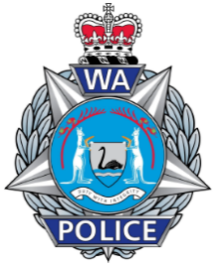

Western Australia Police Force

Reportable Conduct Information Request Form

Pursuant to the Parliamentary Commissioner Act 1971 (PCA)

Section A: Relevant Entity Requesting Information
RELEVANT ENTITY (As per 19I PCA) | HEAD OF RELEVANT ENTITY

Section B: Person Responsible for Investigating Reportable Conduct
NAME | PHONE | EMAIL

I, the person named in Section B, am responsible for investigating the Reportable Conduct outlined in Section C, in accordance with Section 19W(1). To facilitate that investigation, I am requesting the information detailed in Section D.

Section C: Reportable Conduct
ALLEGED OFFENDER NAME | REPORTABLE ALLEGATION / CONVICTION |  | ALLEGED INCIDENT DATE
ALLEGED VICTIM NAME/S | INCIDENT NUMBER (If Known) | OMBUDSMAN WA REFERENCE No.

Section D: Request Details
NOTE: IN MOST CASES, WA POLICE FORCE WILL ONLY PROVIDE INFORMATION WHERE AN INVESTIGATION HAS BEEN FINALISED AND IS NOT PROCEEDING TO PROSECUTION AND WHERE IT IS DETERMINED TO BE IN THE BEST INTERESTS OF A CHILD.
INFORMATION REQUESTED

Please submit this form, along with the following documents to Reportable.Conduct@police.wa.gov.au.
- Ombudsman WA Letter of Assessment.
- If the Investigator (named in Section B) is not the head of the relevant entity, a letter of appointment or delegation nominating the Investigator.

